Introduction to Parkinson’s Disease April 26, 2023
Name: __________________________ Date of Birth:_______________
When was your Parkinson’s Diagnosis (year)? _______________
MAKE SURE A TEAM MEMBER HAS A COPY OF THIS PAGE
Single Leg Balance: Right __________ Left__________
(circle) Below Average Average Above Average
Turning 360°: Right ______ Number of Steps______ Left ______ Number of Steps______
(circle) Below Average Average Above Average
30 Second Sit to Stand: ____________ Arms crossed One Hand No Hands
(circle) Fall Risk Average Above Average
Gait Speed: 3 meters/______ seconds = ________m/s
(circle) Below Average Average Above Average
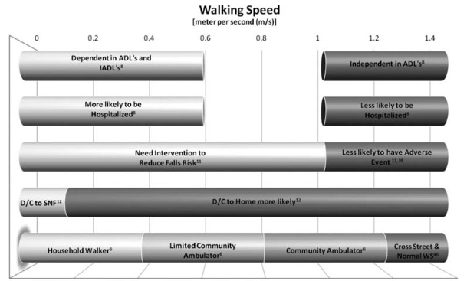
Self Efficacy: https://selfmanagementresource.com/wp-content/uploads/English_-_self-efficacy_for_managing_chronic_disease_6-item.pdf
Pro-PD score https://educationismedicine.com/pro-pd
Take at home, email us your results please PCInfo@rvnahealth.org

