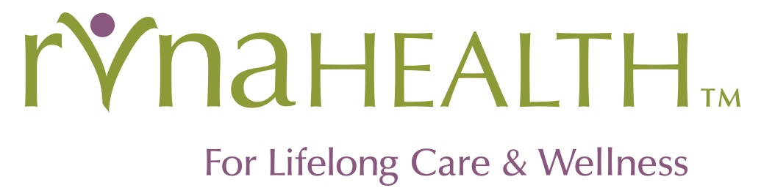

RVNAhealth Marketing Associate – Digital Focus

If interested, please send a cover letter and resume to marketing@rvnahealth.org. Thank you!

Job Summary

The RVNAhealth Marketing Associate is a key member of the (lean, but mighty) RVNAhealth Marketing team, contributing to all departmental initiatives, programs, and channels, with a particular focus on digital channels (website, social media, video).

The ideal candidate for this role is a motivated and experienced marketing professional and team player who can think and act strategically and tactically; will introduce new ideas and approaches as well as work within existing constructs; is able to work both independently and as part of a team; and is comfortable managing projects from inception to completion while managing a body of ongoing work.

The marketing associate will be the primary owner of digital channels (web, social media, video, email marketing, digital advertising), using these tools to tell the RVNAhealth story and promote our programs, services, team and activities. The marketing associate will also manage departmental projects as assigned and will be an overall contributor to marketing and business development strategies.

RVNAhealth is a vital, thriving, mission-driven and forward-thinking not-for-profit organization with a quick pace and a breadth of services and programs. In recent years, RVNAhealth has introduced new services; rebranded and evolved our name; and merged with the Bethel Visiting Nurse Association and New Milford Visiting Nurse & Hospice. We are looking for a Marketing Associate with energy, drive and ambition, looking to grow and progress as RVNAhealth grows and progresses.

Essential Job Functions:
- Contribute to the development and execution of the overall RVNAhealth marketing plan, optimizing existing channels and introducing new ideas and approaches to meet organizational goals.
- Contribute to the development and execution of integrated marketing campaigns that seek to engage and convert RVNAhealth audiences.
- Manage the ongoing development and daily maintenance of RVNAhealth.org, for freshness, clarity, and to align with key business goals and messages.
- Work collaboratively with external resources including developer/designer; writer; RVNAhealth designer;
- Manage all social media marketing across multiple platforms: Facebook, Instagram, Twitter, LinkedIn, Google Business.
- Contribute to the management of the agency’s e-mail marketing calendar, and the creation and delivery of the RVNAhealth newsletters and eblasts across multiple audiences. Track performance, conducts tests, and manage audience lists.
- Create impactful marketing ‘materials’ including, but not limited to: website pages, blog posts, social media posts, graphics, videos.
- Implement digital reporting to identify/ track key metrics indicating effectiveness of channels and campaigns.
- Contribute as needed to all activities and initiatives of the RVNAhealth marketing team.
Required Experience, Skills, Proficiencies, Demeanor:
- Degree in English, marketing, communications, advertising or related field;
- Proven work experience in digital marketing; 3-5+ years of related experience; non-profit background a plus;
- Demonstrated project management experience; self-directed, resourceful, takes initiative and performs well independently;
- Experience managing and maintaining an organizational website (must be adept in WordPress) and collaborating with external web resources (designer/developer, SEO team);
- Fluency in Social Media Marketing with experience with social posts/marketing on Facebook, Twitter, Instagram, LinkedIn, Google Business
- Well-versed in the concepts surrounding digital marketing, content creation, design/development, social media, and email management;
- Strong computer skills including MailChimp, WordPress, Google Analytics Microsoft Outlook, Word, Excel, PowerPoint;
- Experienced and engaging writer (samples required);
- Design skills a plus;
- Must be able to thrive in an energetic, fast-paced, team environment with deadlines; and potentially-competing priorities;
- Creative problem-solving skills; proven ability to recommend and implement process improvements and new initiatives.
# # #

